**USE CASE**

Problem description Write a RESTful web service that schedules messages to be printed. The web service should accept message content and delivery time. The web service should return the 202 status code (accepted) if the message was successfully scheduled. The web service should print the message content on the console at the delivery time specified. The system should recover and messages should not be lost in case of restart.

**Technical constraints**

Keep the solution simple. You can implement the solution using any language or library you know, as long as you provide the instructions on how to run it.

What are we looking for:

A working solution.

Code quality (organization, modularity, modeling, testing ...etc).

Your ability to follow instructions.

Well documented code.

Clearly defined models.

RESTful design.

Database of your choice.

Unit tests Submission

The solution must be saved in a private git repository. The git repository readme file should include information about how to build and run the application

**Background**

Purpose of this Service is to Get message content and delivery time of the message and save it in the DB. This saved message has to be displayed on a Console Application with delivery time

**Pre-requisites to run this Application**,

1)Postman

2)Visual Studio 2019

**Technology stack**

1. Visual studio version with Asp.Net web application
2. Web Api build in C#
3. Sql Server
4. Sql DB with Messages table can be generated using this file(.mdf).Please replace the file location with your folder

Data Source=(LocalDB)\\MSSQLLocalDB;AttachDbFilename=C:\\Users\\Radha\\Documents\\tempdb.mdf;Integrated Security=True;Connect Timeout=30

**SOLUTION:**

I have created a Restful Api api/MessagesAPI using which I can perform all CRUD actions.

1. I have POST a message using the above end point and got a valid response

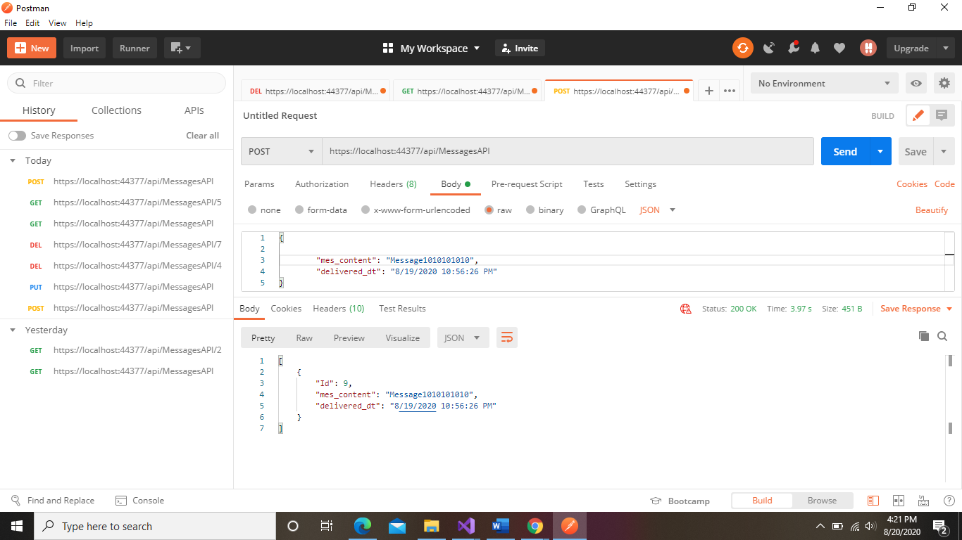

1. I performed GET action to read all the messages in the Database

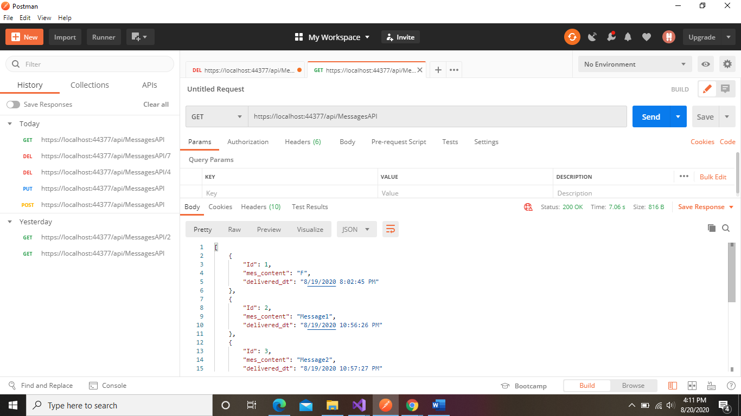

1. I performed GET action to read messages with certain ID in the Database

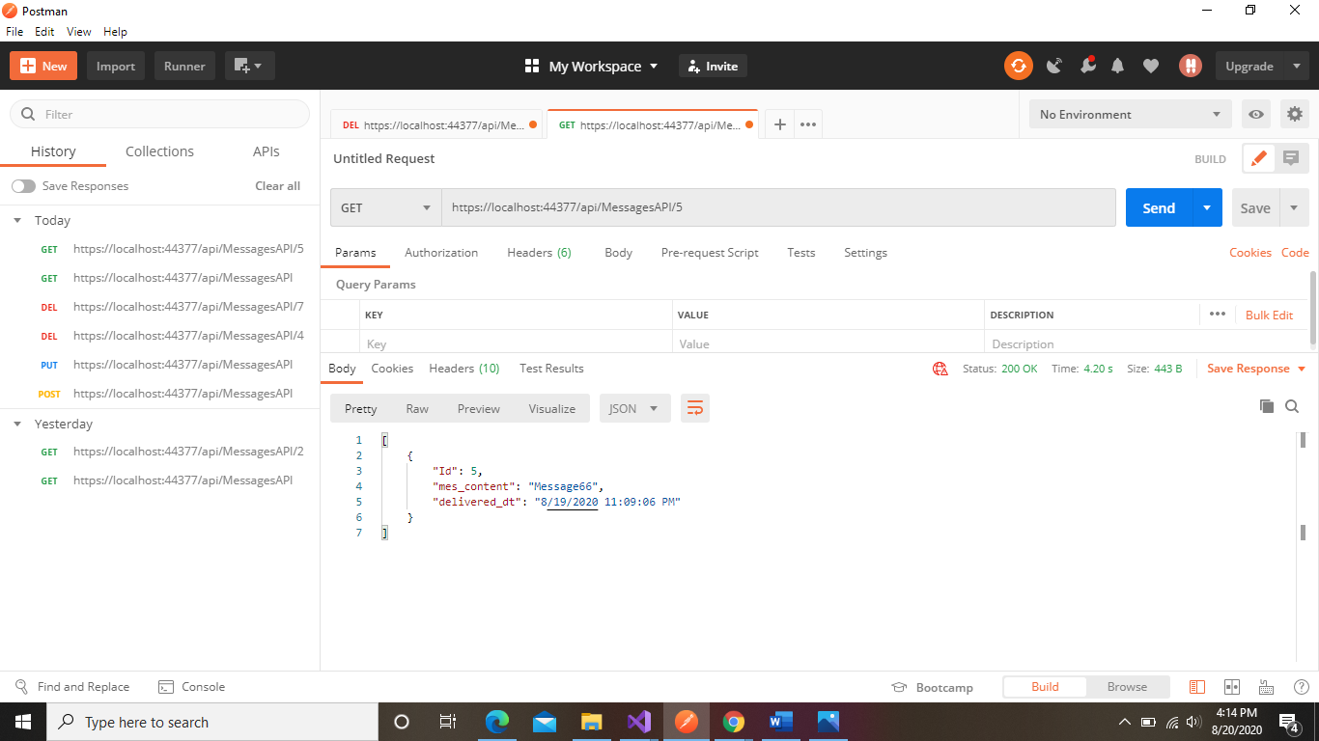

1. I can update any record in the database using this Api end point

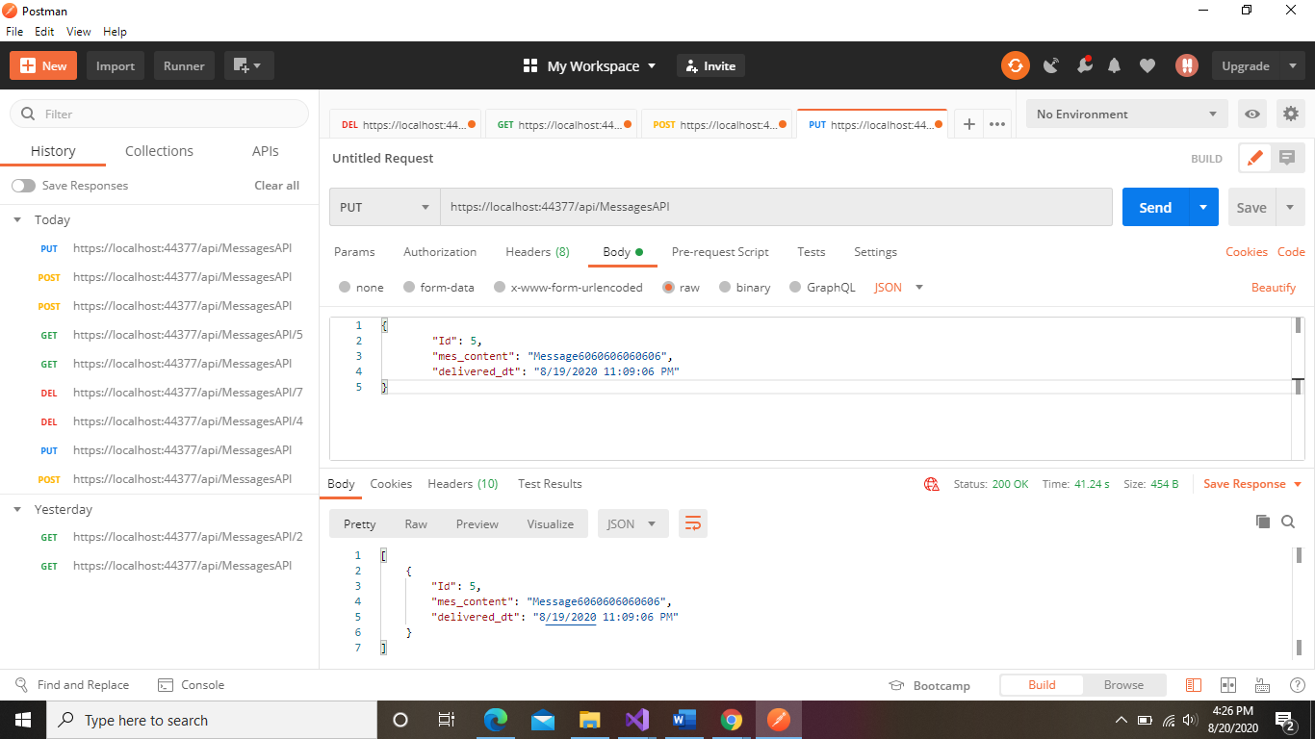

1. I can also delete specific message from DB records

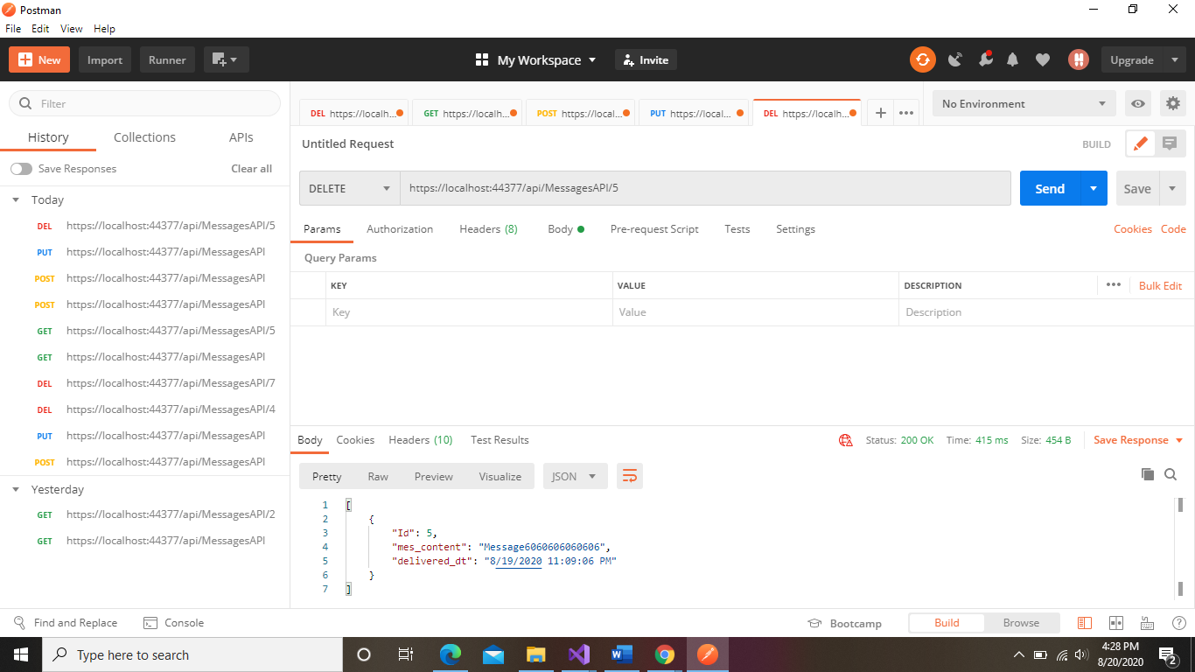

**Run the application**

To run the application

* Download the code onto your local, modify the DB path as mentioned above and set up ypur sql connection.
* First generate some data using the POST method. In the body provide message content and delivery time. You can verify this by doing a get call so that we receive the message back.
* Once the message is inserted into the DB, go to source\repos\New\Messageservice\Consolescheduler\bin\Debug
* open consolescheduler and Press A to get the list of message with delivery time.
* You can press to refresh the page to more messages scheduled for delivery or press B to exit the window